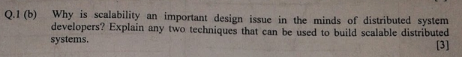

2. What is the role of middleware in a distributed system?

3. If a client and a server are placed far apart, we may see network latency dominating overall performance. How can we tackle this problem?

4. Is a server that maintains a TCP/IP connection to a client stateful or stateless?